



**ITT 450**

**INFORMATION AND NETWORK SECURITY**

PREPARED BY:

**NIK MOHD ASYRAF BIN MOHAMMED (2017373657)**

CLASS:

**M3CS2453A**

PREPARED FOR:

**MOHD ALI BIN MOHD ISA**

***FAKULTI SAINS KOMPUTER DAN MATEMATIK***

UITM MELAKA, KAMPUS JASIN, MELAKA

2017 / 2018

**1) ls**

* Stands for (List Directory Contents). List the contents of the folder, be it files or folder from which it runs.
* 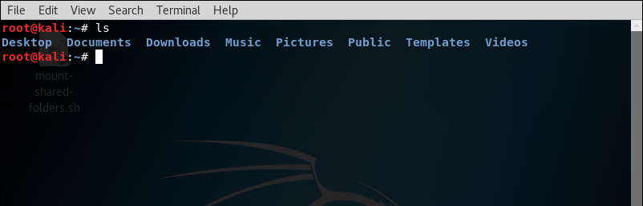Syntax : ls [option][file/dir]

**2) cd**

* Stands for (change directory). It change the working directory to execute, copy, move write and read from terminal itself.
* Syntax : cd.. : to go back one directory

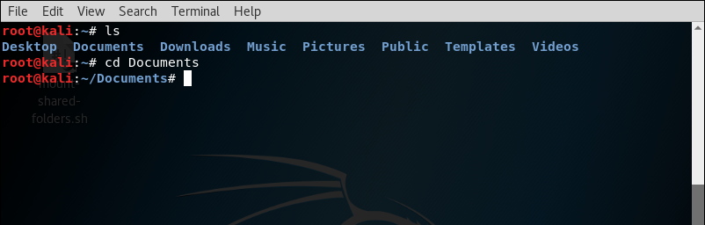 cd Documents : to change into Documents directory

**3) mv**

* Moves a file from one location to another location
* Syntax : - mv [option] [-T] source destination (To rename file)

- mv [option]source[source2 …] destination (To move source file to a directory named destination)

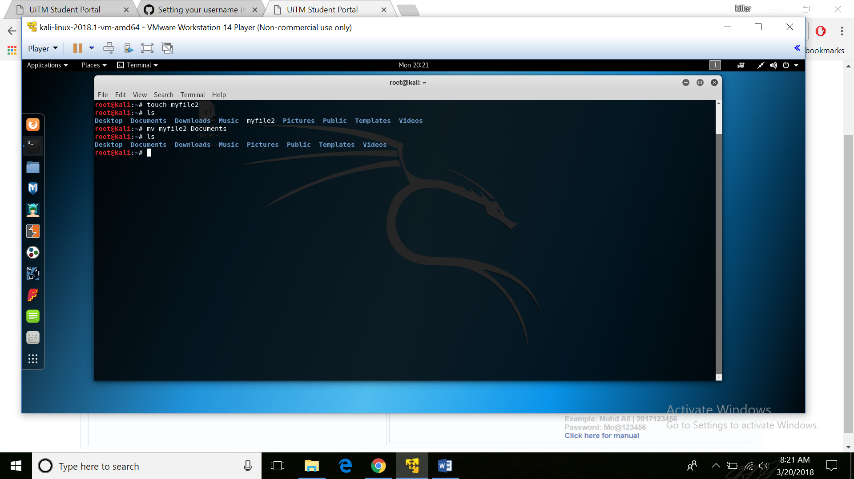

4) **rm**

* Removes files and directory
* Syntax : rm [file]

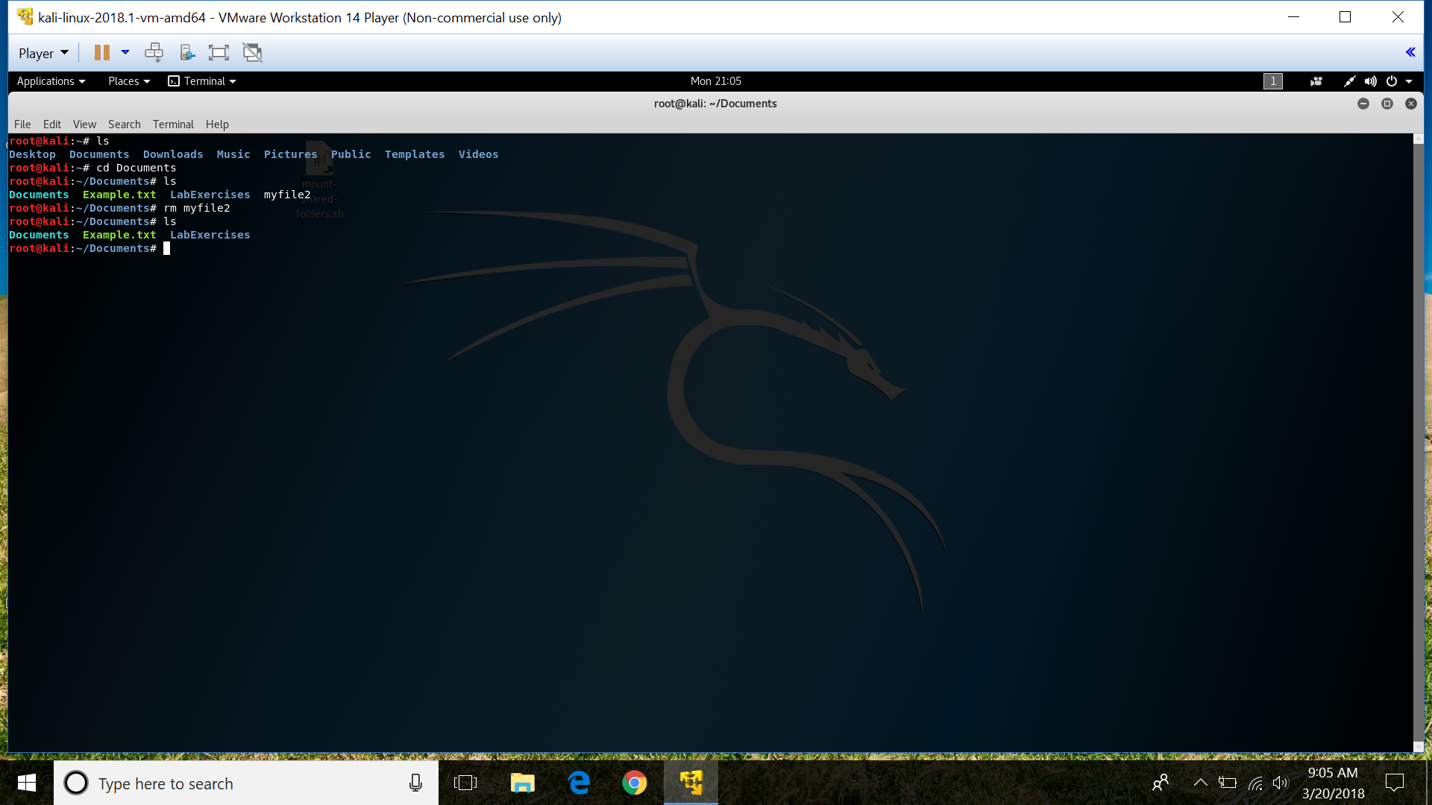

**5) mkdir**

* Creates empty folder
* Syntax : mkdir [option] ‘directory name’

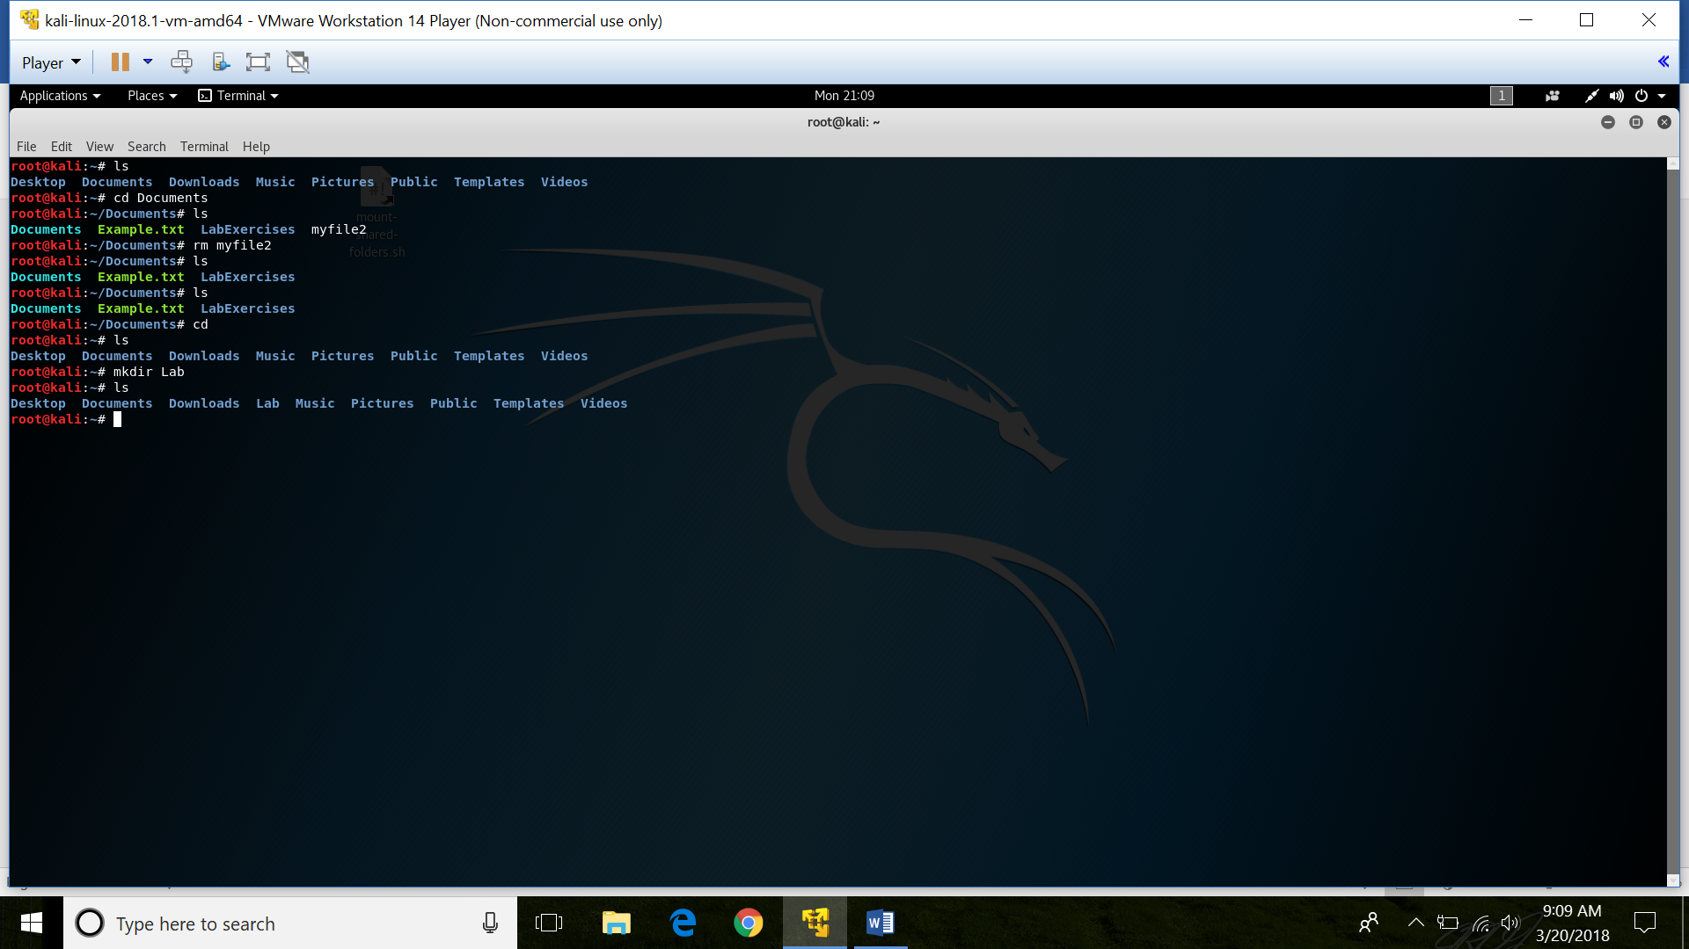

**6)** **rmdir**

* Remove empty directories from your file system
* Syntax : rmdir [option] ‘directory name’

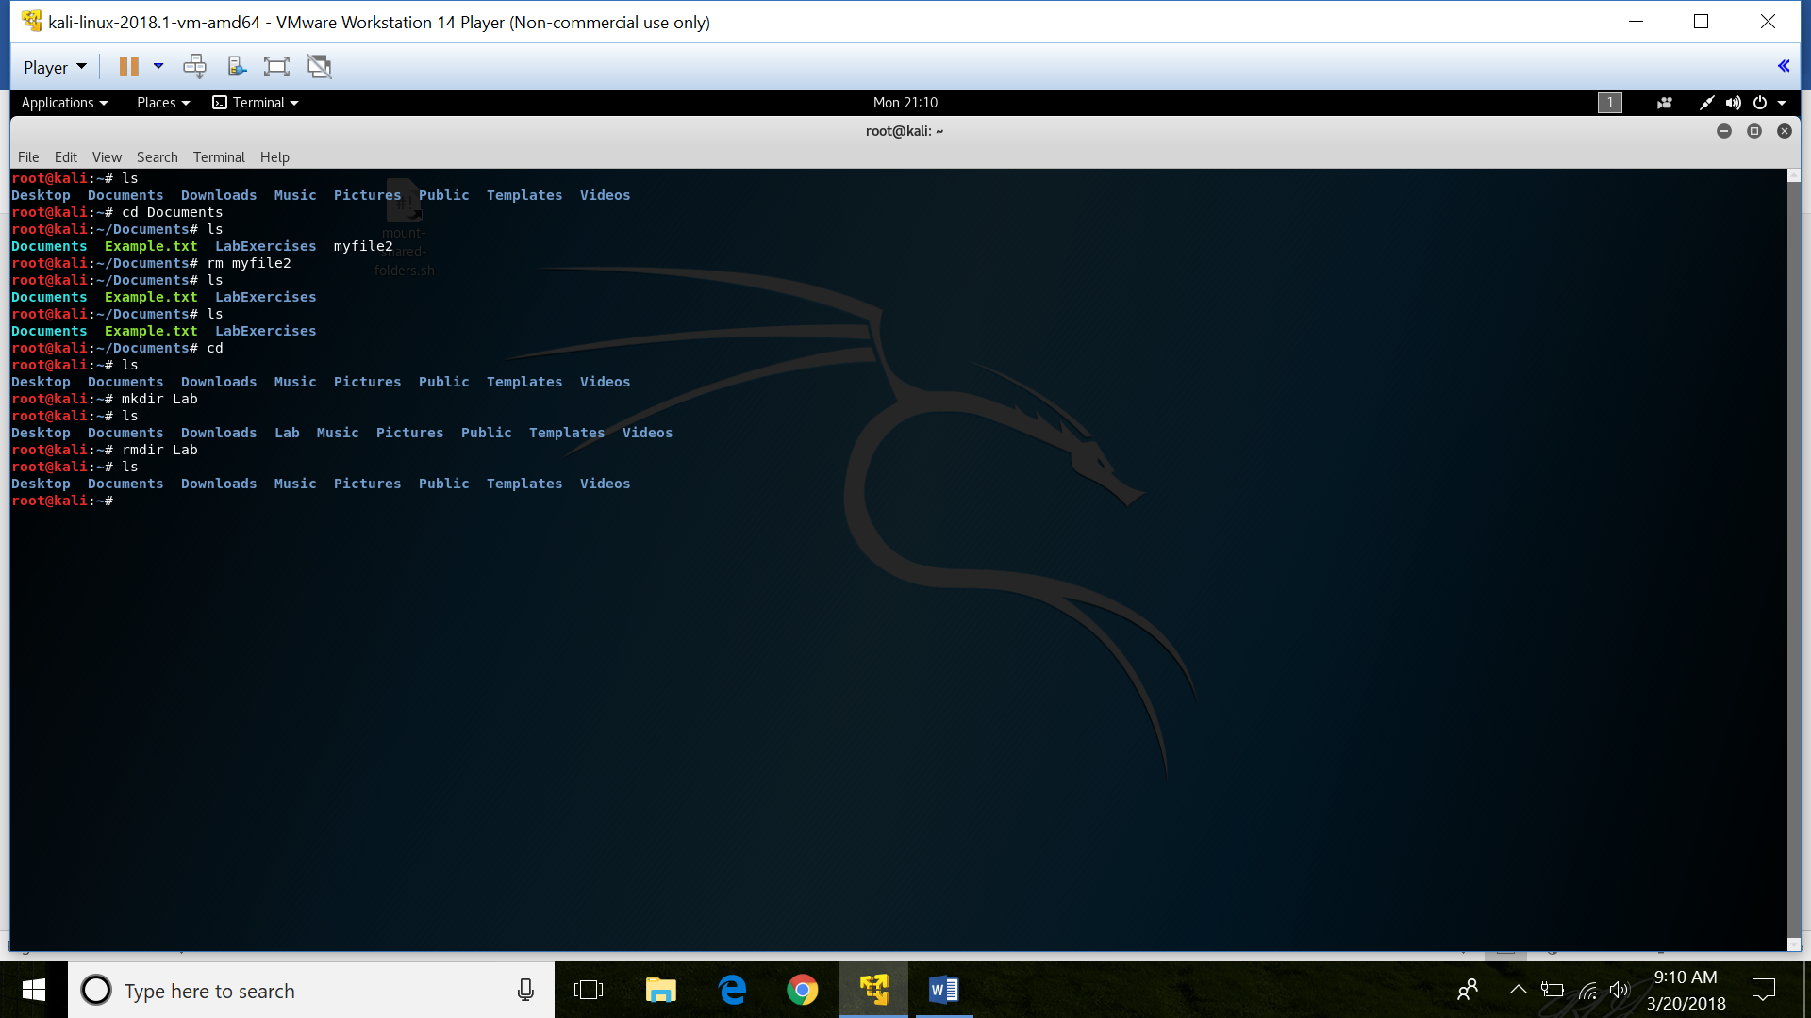

**7) touch**

* Create new empty files and also used to change the timestamps
* Syntax : touch [option] ‘file name’

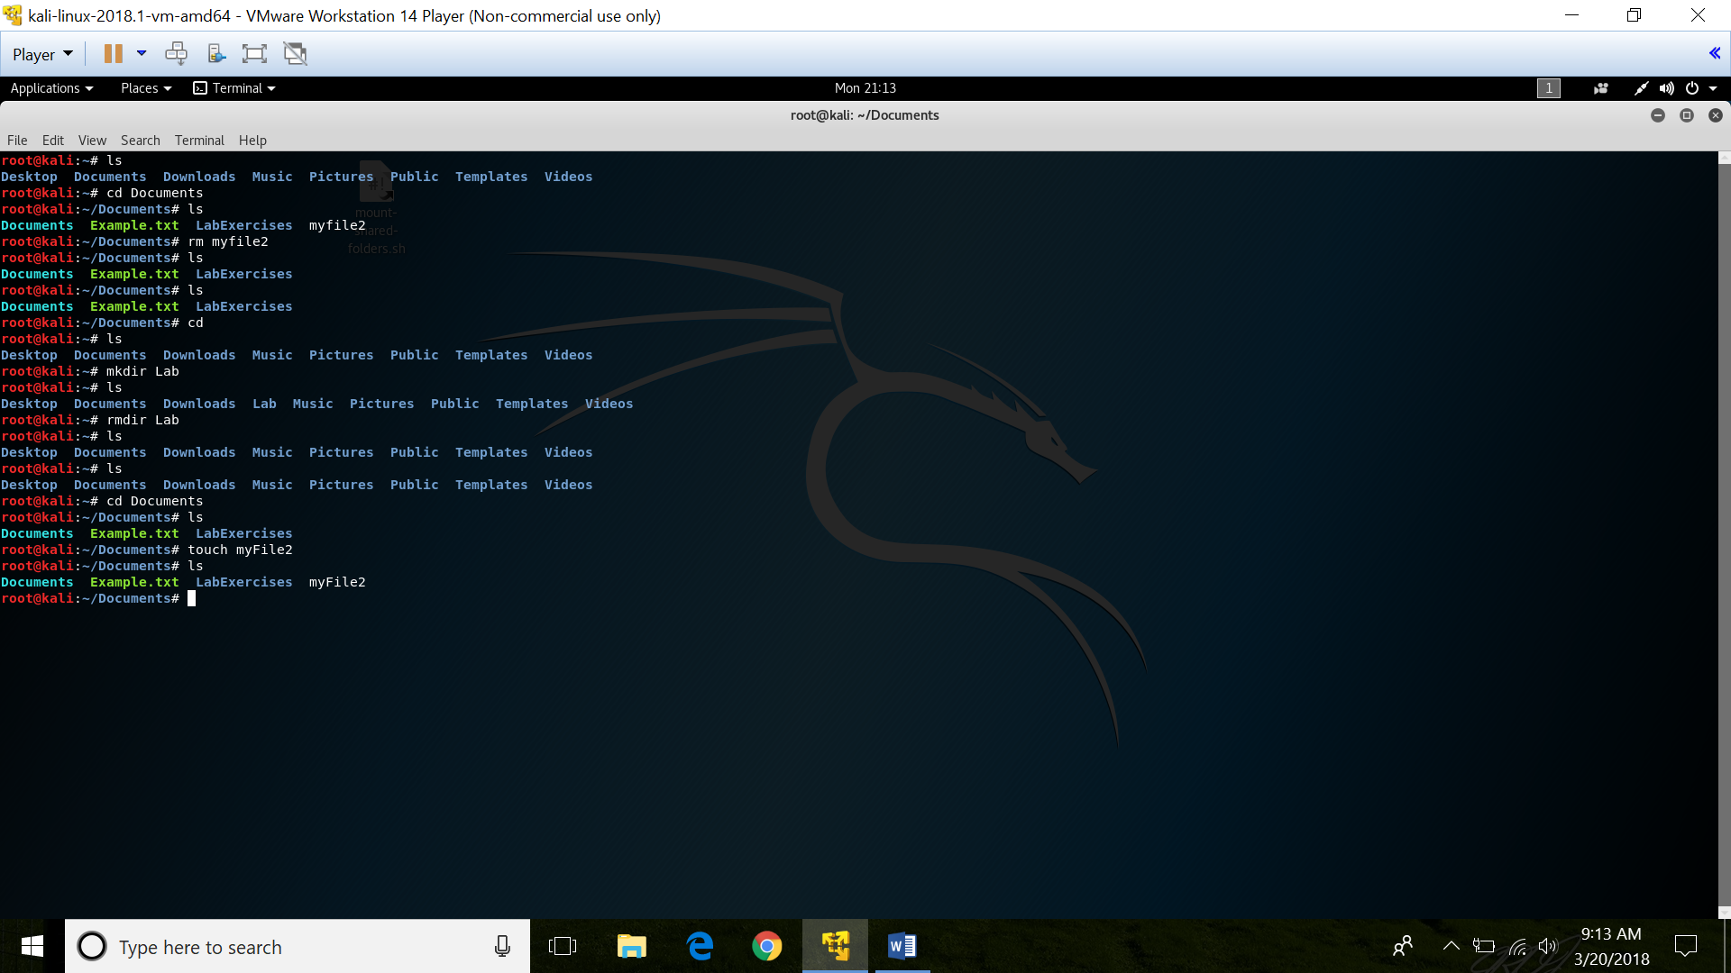

**8) cat**

* Allows us to create single or multiple files, view contain of file, concatenate files and redirect output in terminal or files
* Syntax : cat [option] [file] …

cat > ‘file name’ (Create a file)

cat ‘file name’ (To display a file)

cat >> ‘file name’ (To add data into existing file)

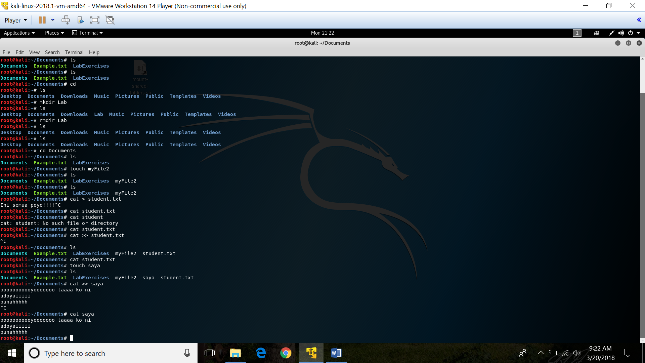

**9) pwd**

* Print working directory
* Syntax : pwd [option]

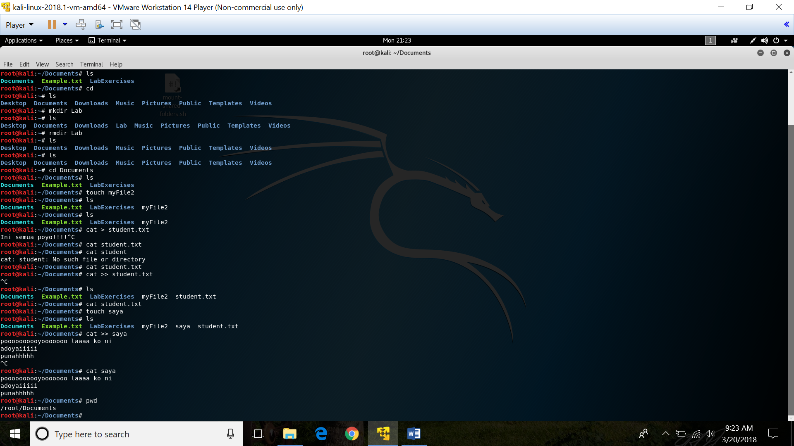

**10)** **file**

* To determine a file’s type
* Syntax : file [filename]

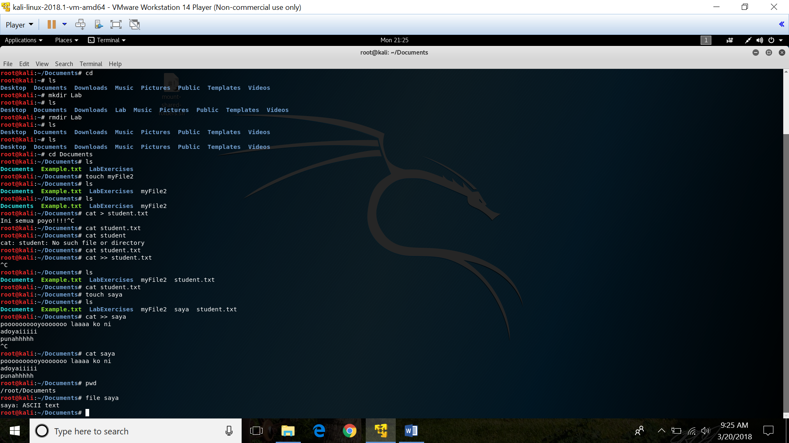

**11)** **ln**

* To create a link to a file target with the name LINKNAME. If LINKNAME is omitted, a link to target is created in the current directory using the name of target as the LINKNAME
* Syntax : ln [option] [filename]

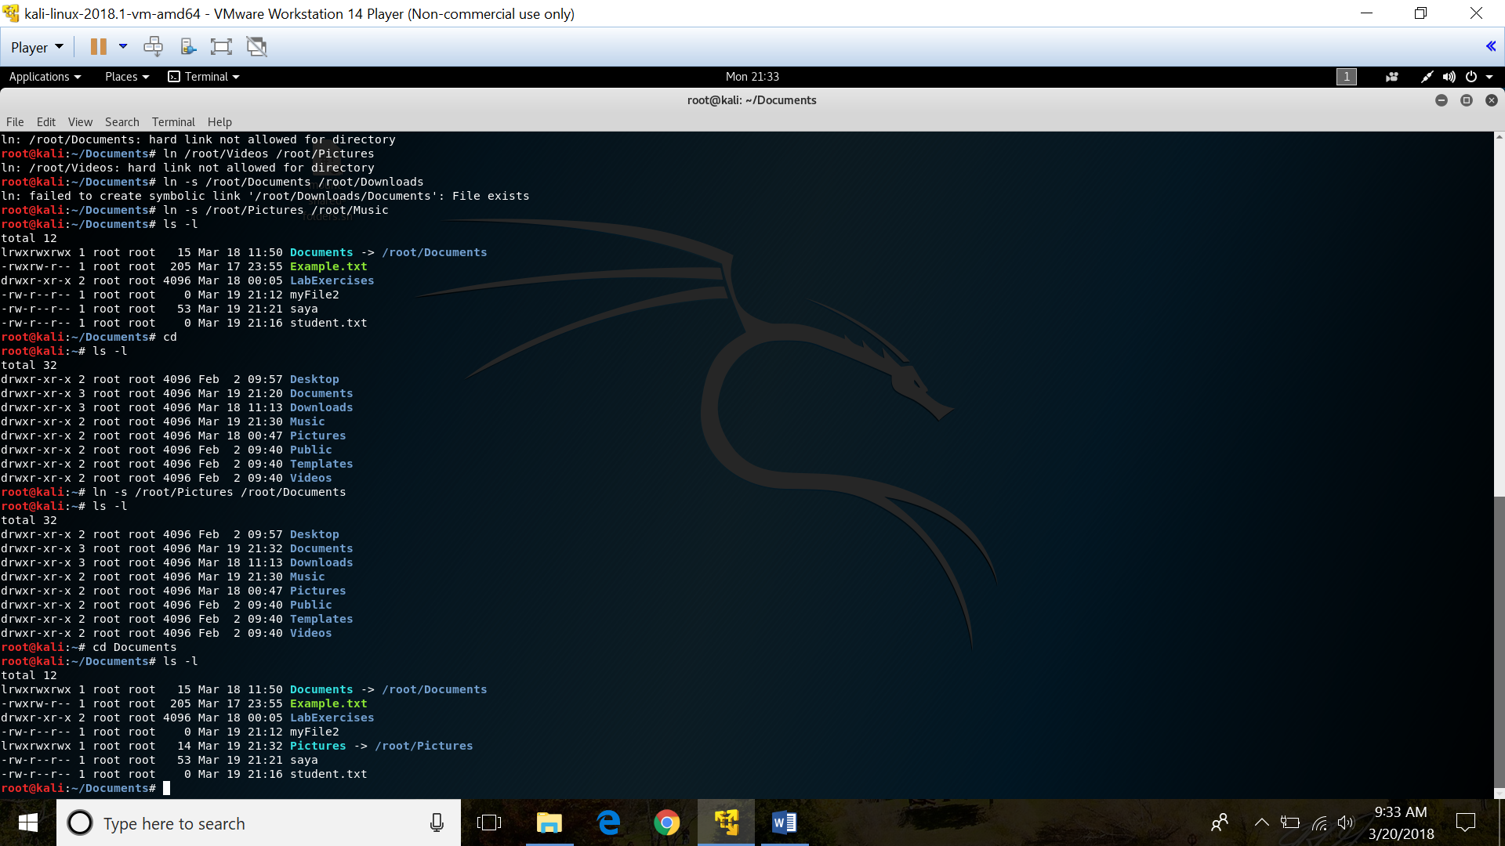

**12) chmod**

* Used to change file access permissions such as read, write and access
* Syntax : chmod [options] [permission] [filename]

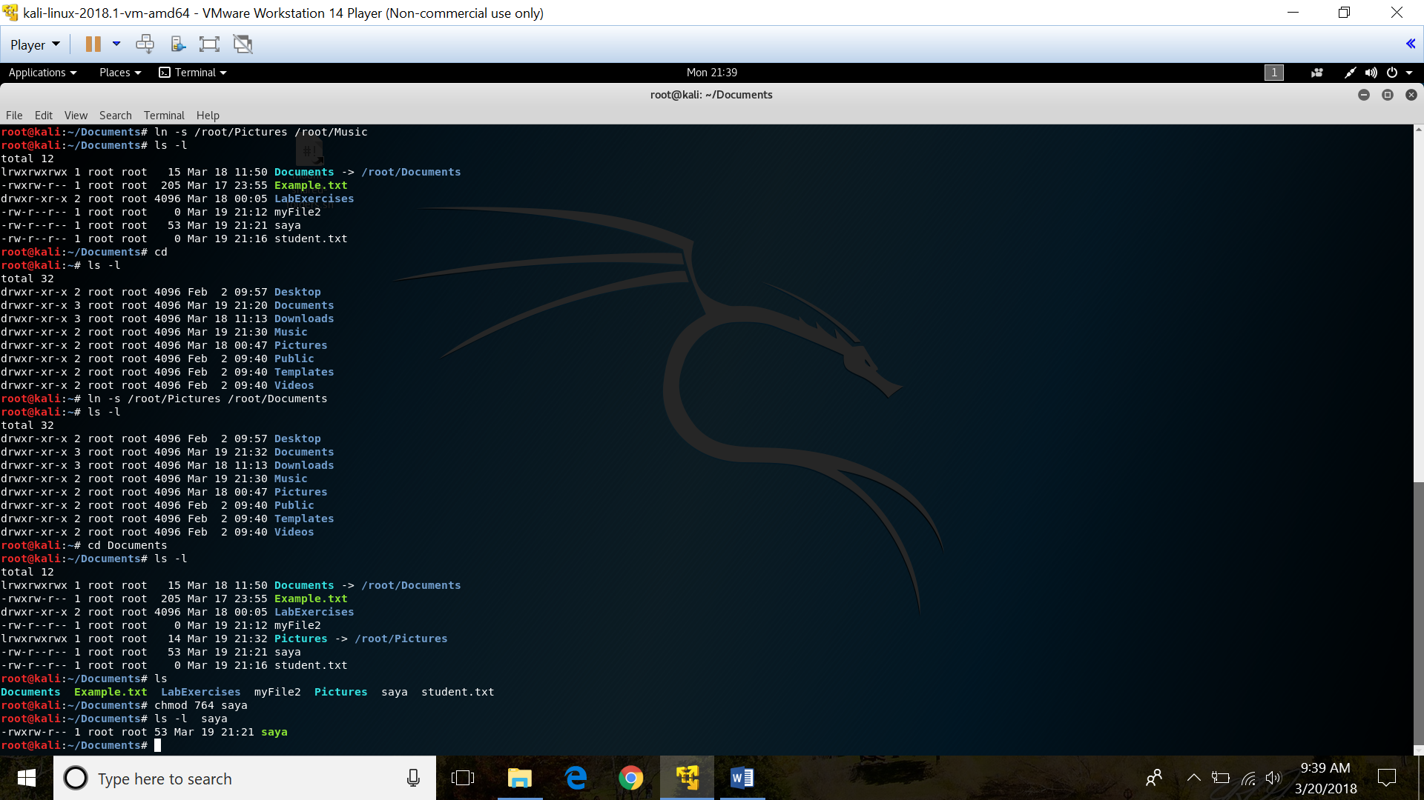

**13) chown**

* Used to change file owner and group information
* Syntax : chown [option] [filename]

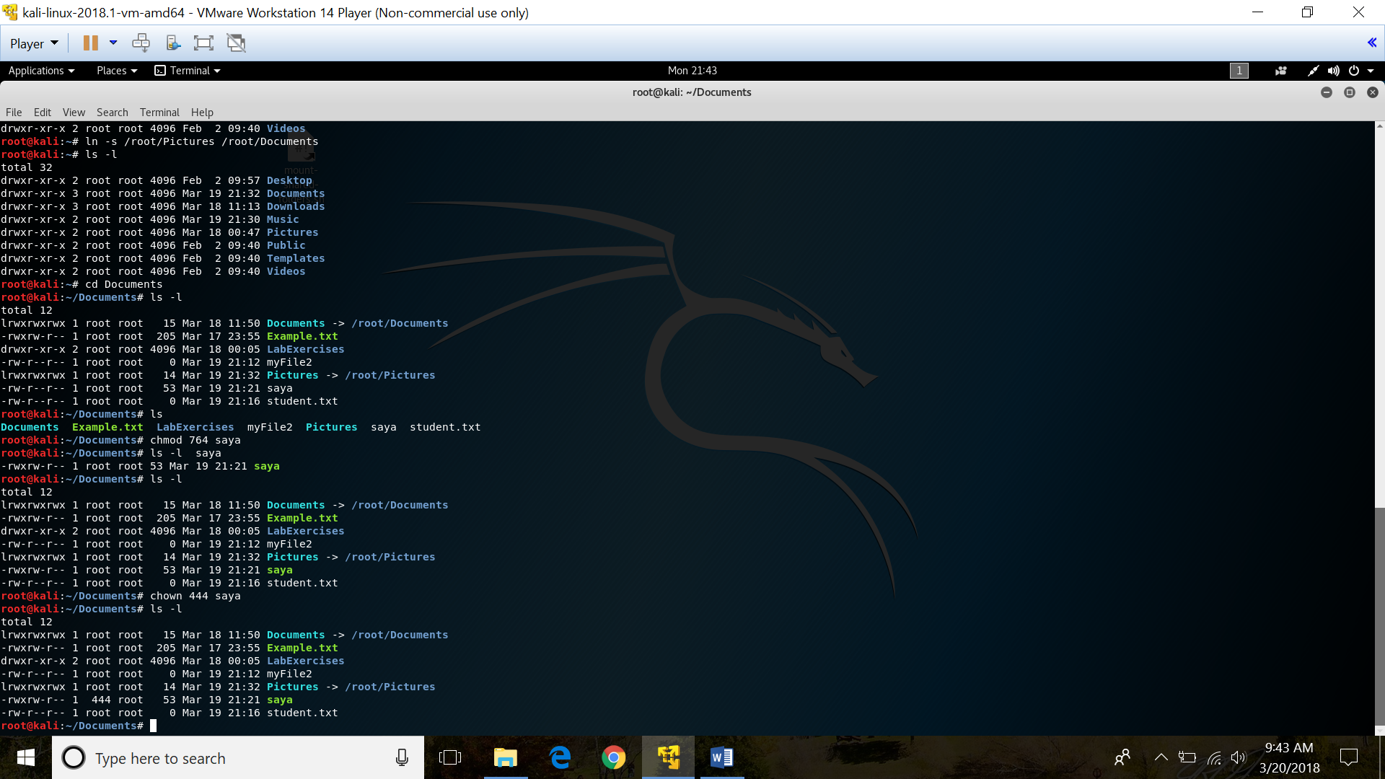

**14)** **more / less**

* More : To view a text file one page at a time
* Syntax : more [options] filename
* Less : Similar to more but allows backward movement in the file as well as forward movement. Also, less does not have to read the entire input file before starting, so with large input files it starts up faster than text editors.
* Syntax : less [option] filename

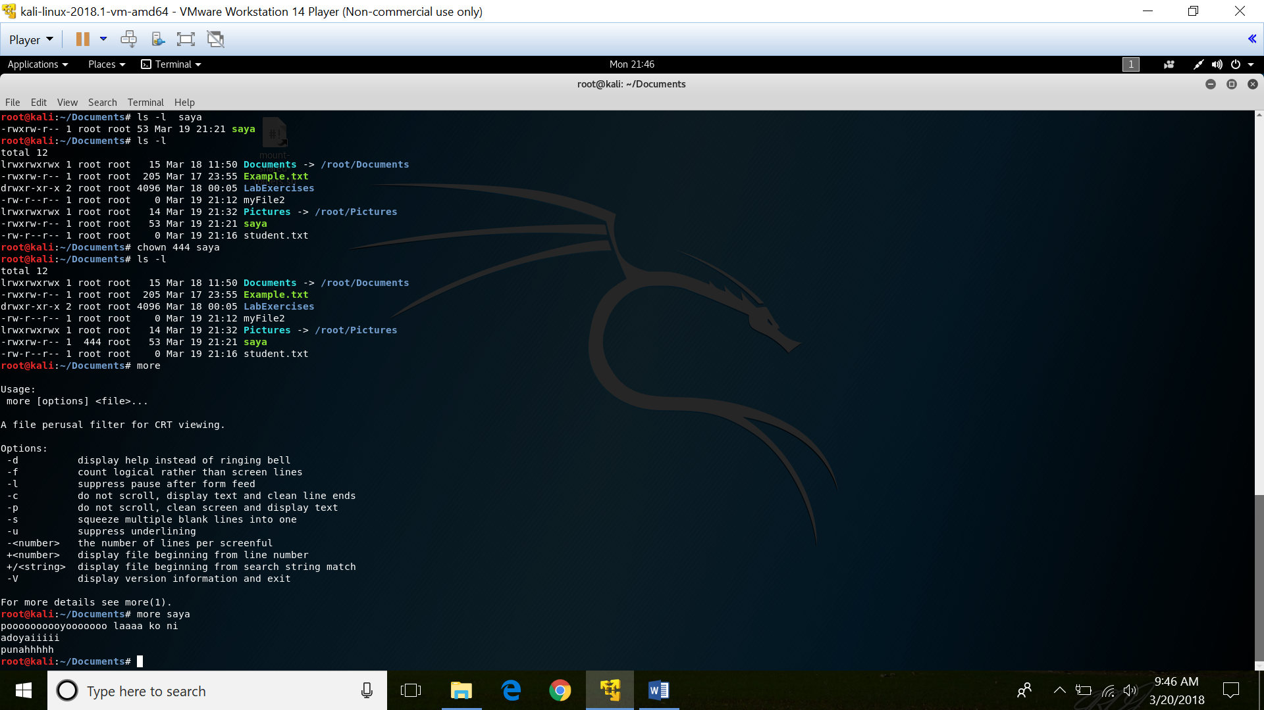

**15)** **grep**

* To search a word in a line and prints any line which match a specified pattern
* Syntax : grep [options] PATTERN [file..]

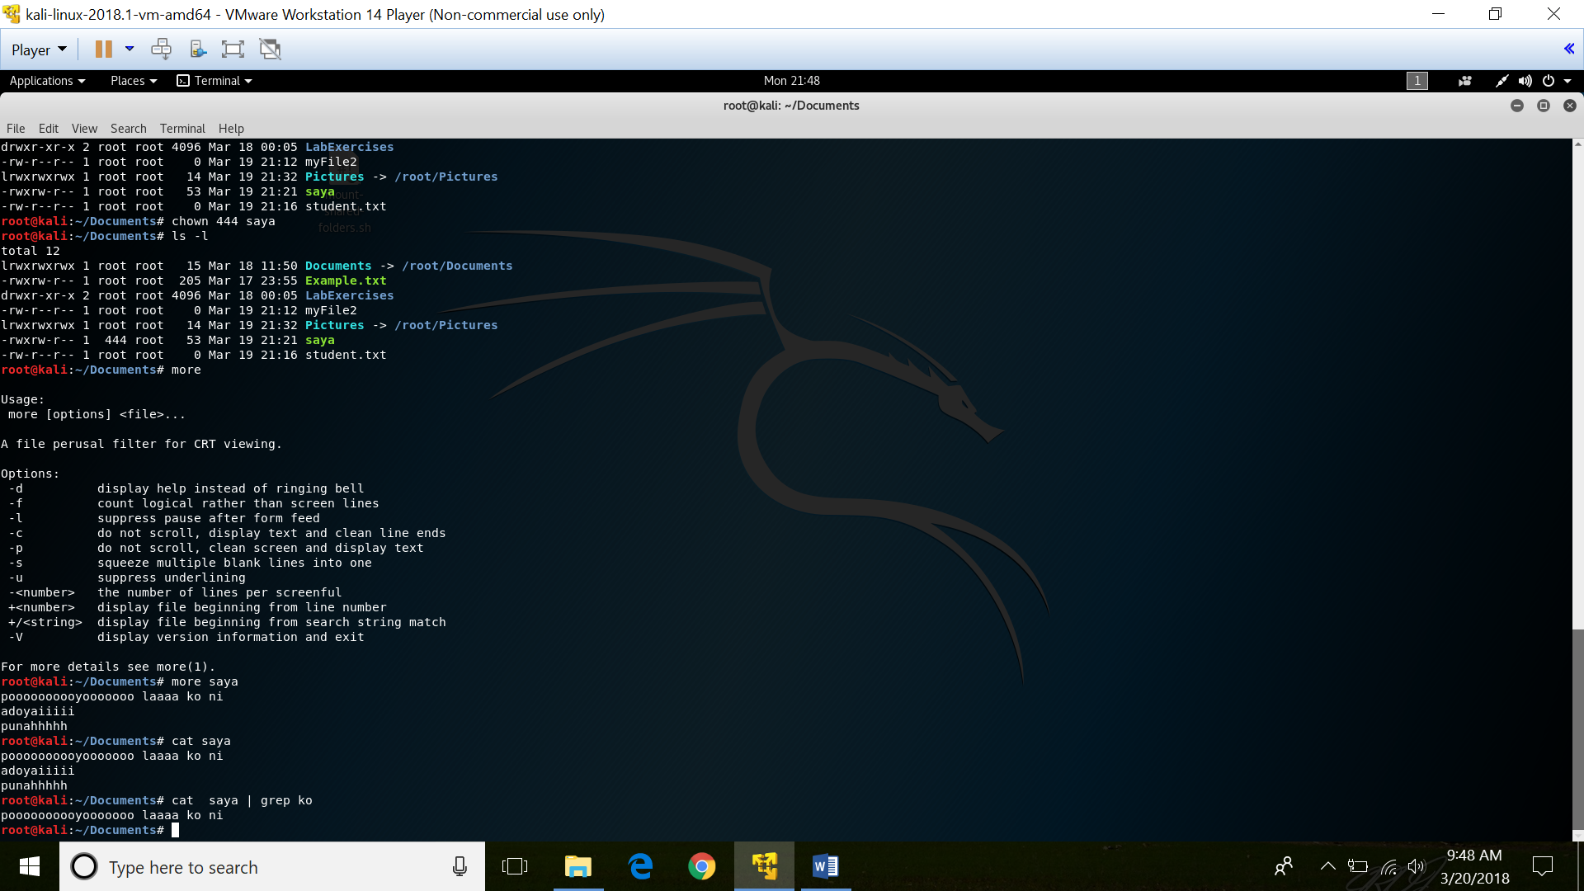

**16) wc**

* To find out the number of newline count, word count, byte and characters count in a files specified by the files arguments
* Syntax : wc [options] filename
* wc –l : Prints the number of lines in a file
* wc –w : Prints the number of words in a file
* wc –c : Display the count of bytes in a file
* wc –m : Prints the count of characters from a file
* wc –L : Prints only the length of the longest line in a file

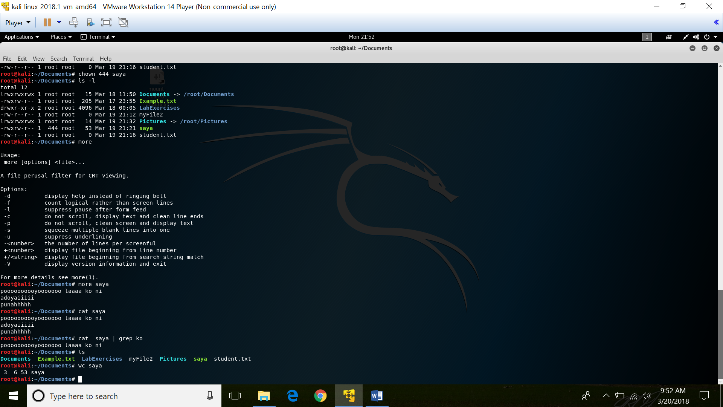

**17) kill**

* Terminate a process
* Syntax : kill [signal or options] PID(s)

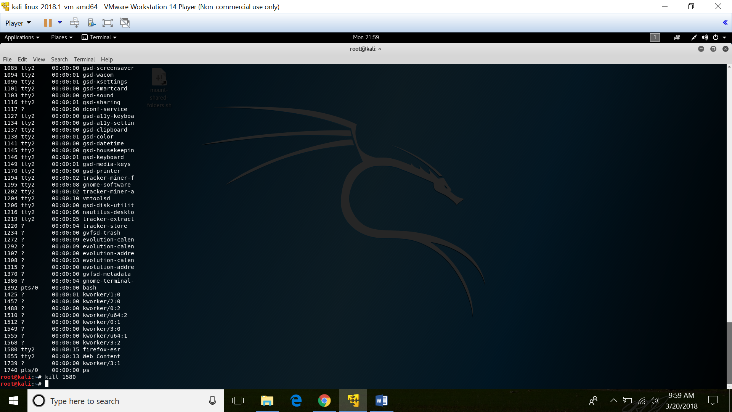

**18) ps**

* To provide information about the processes running on the system
* Syntax : ps [options]

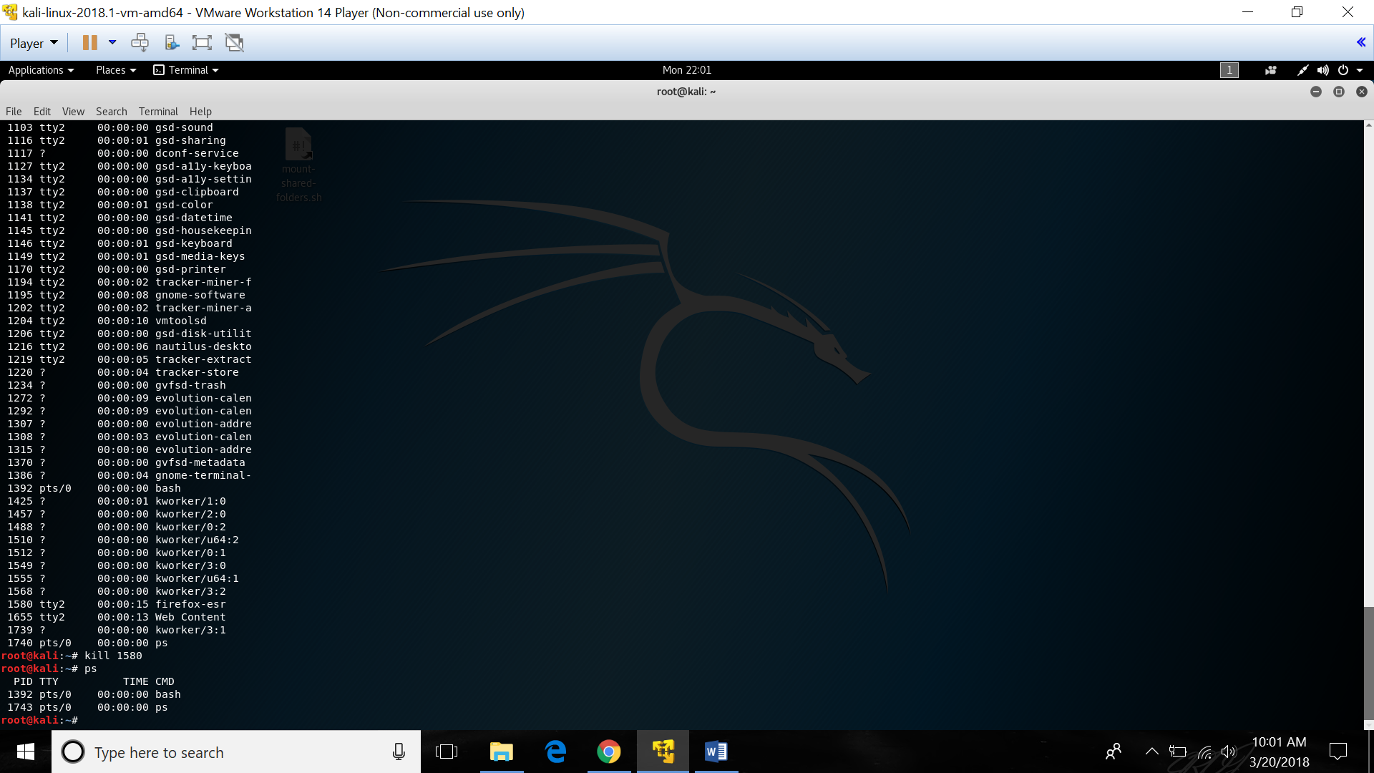

**19) uname**

* Display detailed information about the machine name, Operating System and Kernel
* Syntax : uname [option]

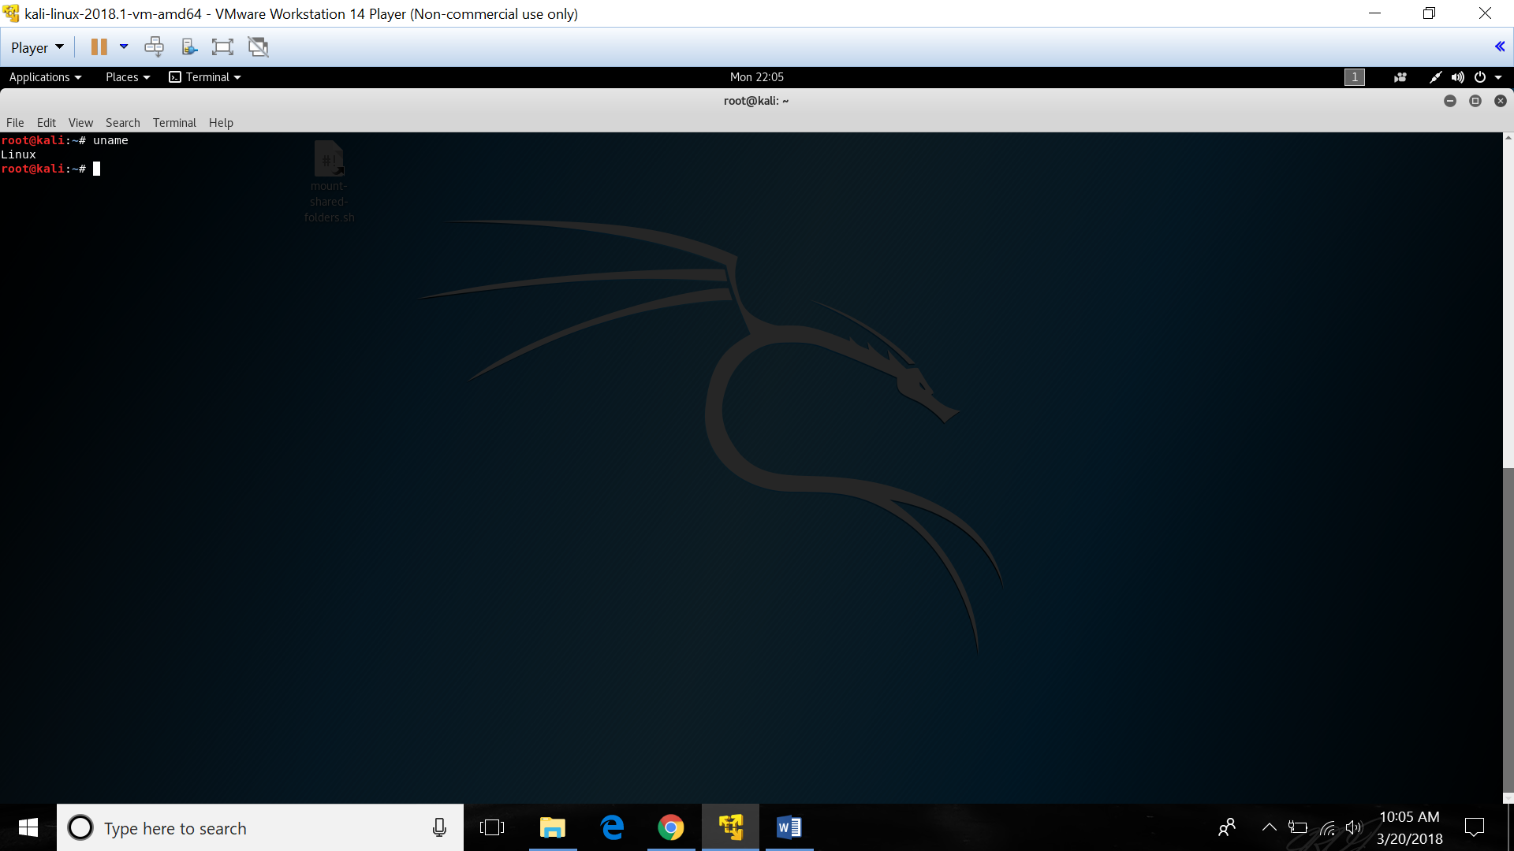

**20) top**

* Shows the top processes based on certain criteria like cpu usage or memory usage
* Syntax : top

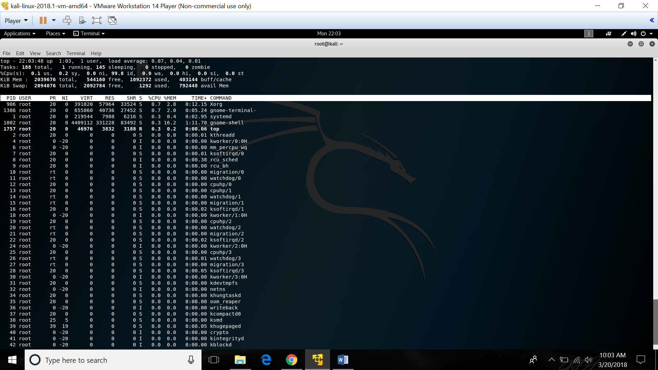

**21)** **uptime**

* To check how long your system is running
* Syntax : uptime

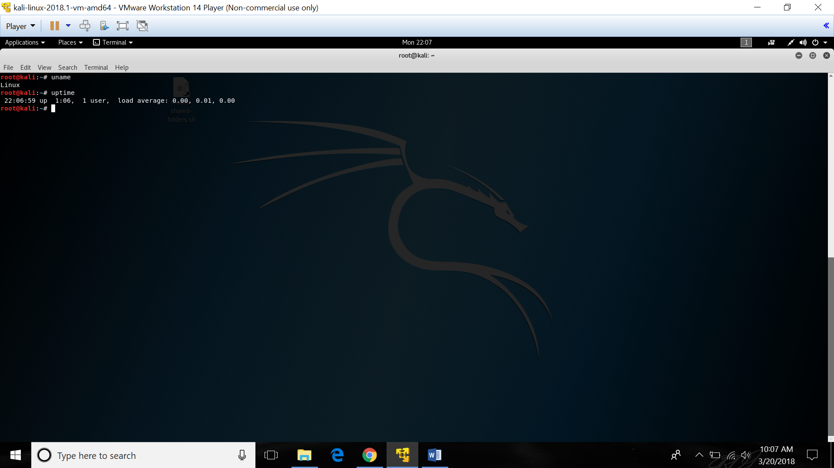

**22)** **ping**

* To send ICMP ECHO_REQUEST packets to network host. It is frequently used to test the connection and latency between two network connections
* Syntax : ping [option] [destination]

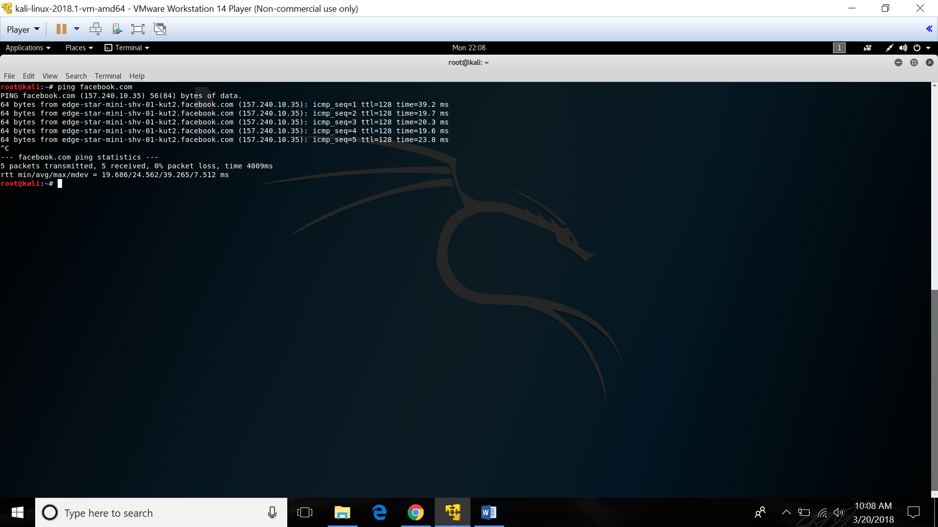

**23)** **netstat**

* Monitoring network connections both incoming and outgoing as well as viewing routing tables and interface statistics
* Syntax : netstat

